BIOGRAPHY
My name is Bryan Morales Stiven. Was born in 2000 knowing only my mother, my father and mother separated when I was born, my mom took me to Medellin raising me there alone for a year.
At six I know my father, my father and my mother was agreed for me to visit my father every 15 days, reaching this has has come to live with my father at age 9.
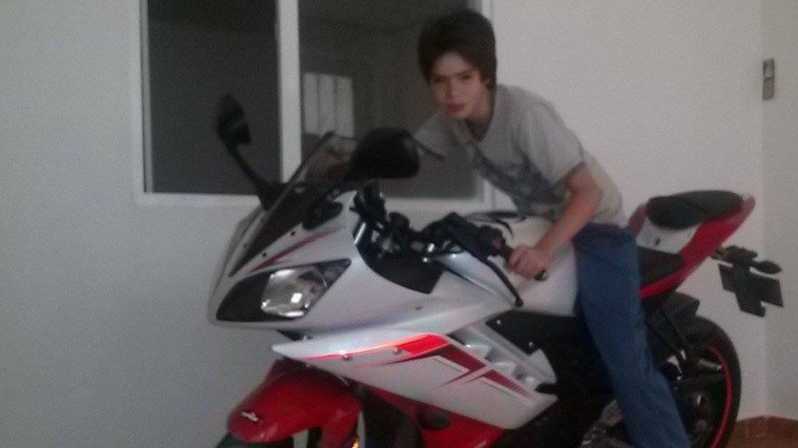
My religion is Christian because that chose voluntary mind, my hobbit is basketball because I've been practicing for 3 years

